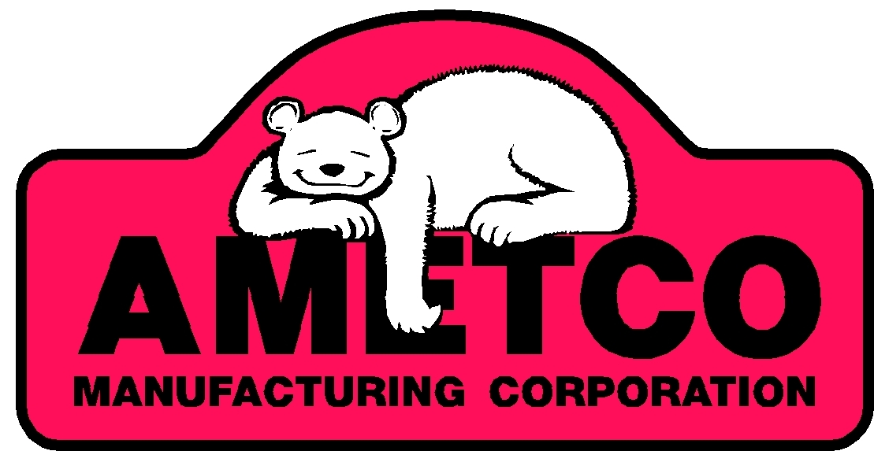

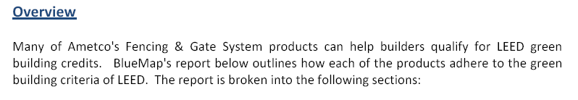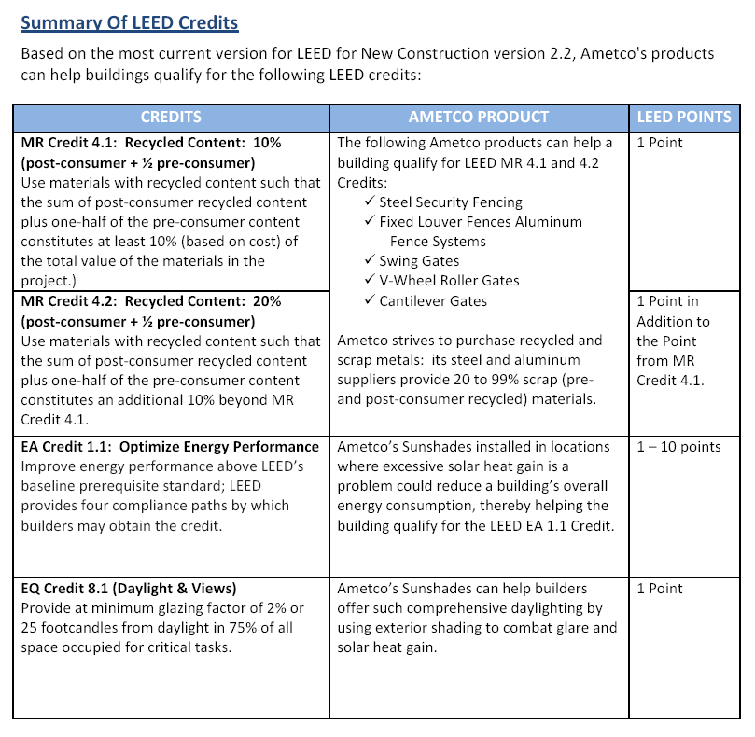

Ametco powder coating process is solvent free. The powder is formulated using finely ground pigments and resins with zero solvents resulting in a clean air finish and next to zero VOCs. The electrostatic powder to substrate process equates to very little overspray of which 98% can be retrieved and reused. This would qualify for LEED points only if it is used indoors.

Ametco is continuing to work on improving our product line. These changes may increase the LEED points your projects can earn.

Existing LEED compliance and opportunities report prepared for Ametco Manufacturing Corp. by:



